SPTECH Silicon NPN Power Transistor 2SD1047

DESCRIPTION
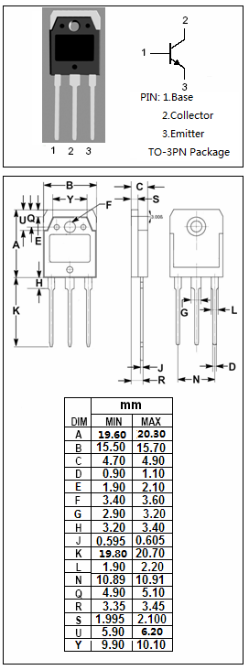
·Collector-Emitter Breakdown Voltage-
: V_{(BR)CEO}= 140V(Min)
·Good Linearity of h_{FE}
·High Current Capability
·Wide Area of Safe Operation
·Complement to Type 2SB817

APPLICATIONS
·Recommend for 60W audio frequency amplifier output
stage applications

ABSOLUTE MAXIMUM RATINGS(T_{a}=25℃)
SYMBOL | PARAMETER | VALUE | UNIT
V_{CBO} | Collector-Base Voltage | 160 | V
V_{CEO} | Collector-Emitter Voltage | 140 | V
V_{EBO} | Emitter-Base Voltage | 6 | V
I_{C} | Collector Current-Continuous | 12 | A
I_{CP} | Collector Current-Pulse | 15 | A
P_{C} | Collector Power Dissipation  @ T_{C}=25℃ | 100 | W
T_{J} | Junction Temperature | 150 | ℃
T_{stg} | Storage Temperature Range | -40~150 | ℃

SPTECH Silicon NPN Power Transistor 2SD1047

ELECTRICAL CHARACTERISTICS
T_{C}=25℃ unless otherwise specified
SYMBOL | PARAMETER | CONDITIONS | MIN | TYP. | MAX | UNIT
V_{(BR)CEO} | Collector-Emitter Breakdown Voltage | I_{C}= 30mA ; R_{BE}= ∞ | 140 |  |  | V
V_{(BR)CBO} | Collector-Base Breakdown Voltage | I_{C}=1mA; I_{E}= 0 | 160 |  |  | V
V_{(BR)EBO} | Emitter-Base Breakdown Voltage | I_{E}= 5mA; I_{C}= 0 | 6 |  |  | V
V_{CE(sat)} | Collector-Emitter Saturation Voltage | I_{C}= 5.0A; I_{B}= 0.5A |  | 0.6 | 2.5 | V
V_{BE(on)} | Base -Emitter On Voltage | I_{C}= 1A ; V_{CE}= 5V |  |  | 1.5 | V
I_{CBO} | Collector Cutoff Current | V_{CB}= 80V ; I_{E}= 0 |  |  | 100 | μA
I_{EBO} | Emitter Cutoff Current | V_{EB}= 4V; I_{C}= 0 |  |  | 100 | μA
h_{FE-1} | DC Current Gain | I_{C}= 1A ; V_{CE}= 5V | 60 |  | 200
h_{FE-2} | DC Current Gain | I_{C}= 6A ; V_{CE}= 5V | 20
C_{OB} | Output Capacitance | I_{E}= 0;V_{CB}= 10V;f_{test}= 1.0MHz |  | 210 |  | pF
f_{T} | Current-Gain—Bandwidth Product | I_{C}= 1A ; V_{CE}= 5V |  | 15 |  | MHz
Switching times
t_{on} | Turn-on Time | I_{C}= 1A ,R_{L}= 20Ω,  I_{B1}= I_{B2}= 0.1A,V_{CC}= 20V |  | 0.26 |  | μs
t_{stg} | Storage Time | I_{C}= 1A ,R_{L}= 20Ω,  I_{B1}= I_{B2}= 0.1A,V_{CC}= 20V |  | 6.88 |  | μs
t_{f} | Fall Time | I_{C}= 1A ,R_{L}= 20Ω,  I_{B1}= I_{B2}= 0.1A,V_{CC}= 20V |  | 0.68 |  | μs

- h_{FE-1} Classifications
D | E
60-120 | 100-200

