SPTECH Silicon PNP Power Transistor 2SB688

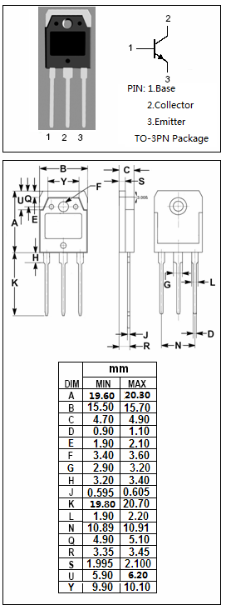
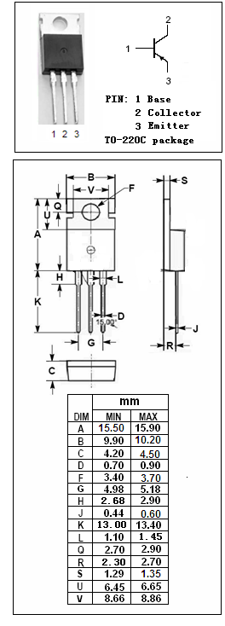

DESCRIPTION
·Collector-Emitter Breakdown Voltage-
: V_{(BR)CEO}= -120V(Min)
·Good Linearity of h_{FE}
·Complement to Type 2SD718

APPLICATIONS
·Audio frequency power amplifier applications
·Recommend for 45-50W audio frequency amplifier
output stage applications

ABSOLUTE MAXIMUM RATINGS(T_{a}=25℃)
SYMBOL | PARAMETER | VALUE | UNIT
V_{CBO} | Collector-Base Voltage | -120 | V
V_{CEO} | Collector-Emitter Voltage | -120 | V
V_{EBO} | Emitter-Base Voltage | -5 | V
I_{C} | Collector Current-Continuous | -8 | A
I_{B} | Base Current-Continuous | -0.8 | A
P_{C} | Collector Power Dissipation  @ T_{C}=25℃ | 80 | W
T_{J} | Junction Temperature | 150 | ℃
T_{stg} | Storage Temperature Range | -55~150 | ℃

SPTECH Silicon PNP Power Transistor 2SB688

ELECTRICAL CHARACTERISTICS
T_{C}=25℃ unless otherwise specified
SYMBOL | PARAMETER | CONDITIONS | MIN | TYP. | MAX | UNIT
V_{(BR)CEO} | Collector-Emitter Breakdown Voltage | I_{C}= -50mA ; I_{B}= 0 | -120 |  |  | V
V_{CE(sat)} | Collector-Emitter Saturation Voltage | I_{C}= -5.0A; I_{B}= -0.5A |  |  | -2.5 | V
V_{BE(on)} | Base-Emitter On Voltage | I_{C}= -5A ; V_{CE}= -5V |  |  | -1.5 | V
I_{CBO} | Collector Cutoff Current | V_{CB}= -120V ; I_{E}= 0 |  |  | -10 | μA
I_{EBO} | Emitter Cutoff Current | V_{EB}= -5V; I_{C}= 0 |  |  | -10 | μA
h_{FE} | DC Current Gain | I_{C}= -1A ; V_{CE}= -5V | 55 |  | 160
C_{OB} | Output Capacitance | I_{E}= 0; V_{CB}= -10V; f_{test}= 1.0MHz |  | 280 |  | pF
f_{T} | Current-Gain—Bandwidth Product | I_{C}=-1A ; V_{CE}= -5V |  | 10 |  | MHz

- h_{FE} Classifications
R | O
55-110 | 80-160

