SPTECH Silicon NPN Power Transistor 2SC3866

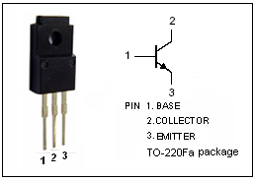
DESCRIPTION
·High Breakdown Voltage
: V_{(BR)CBO}= 900V(Min)
·High Switching Speed
·High Reliability

APPLICATIONS
·Switching regulators
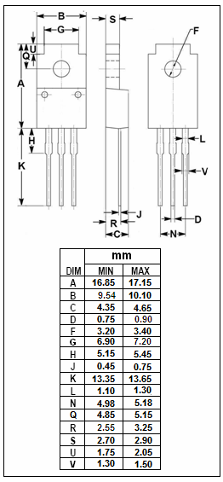
·Ultrasonic generators
·High frequency inverters
·General purpose power amplifiers

ABSOLUTE MAXIMUM RATINGS(T_{a}=25℃)
SYMBOL | PARAMETER | VALUE | UNIT
V_{CBO} | Collector-Base Voltage | 900 | V
V_{CEO} | Collector-Emitter Voltage | 800 | V
V_{EBO} | Emitter-Base Voltage | 10 | V
I_{C} | Collector Current-Continuous | 3 | A
I_{B} | Base Current-Continuous | 1 | A
P_{C} | Collector Power Dissipation  @ T_{C}=25℃ | 40 | W
T_{J} | Junction Temperature | 150 | ℃
T_{stg} | Storage Temperature Range | -55~150 | ℃

THERMAL CHARACTERISTICS
SYMBOL | PARAMETER | MAX | UNIT
R_{th j-c} | Thermal Resistance,Junction to Case | 3.0 | ℃/W

SPTECH Silicon NPN Power Transistor 2SC3866

ELECTRICAL CHARACTERISTICS
T_{C}=25℃ unless otherwise specified
SYMBOL | PARAMETER | CONDITIONS | MIN | TYP. | MAX | UNIT
V_{(BR)CEO} | Collector-Emitter Breakdown Voltage | I_{C}= 10mA; I_{B}= 0 | 800 |  |  | V
V_{(BR)CBO} | Collector-Base Breakdown Voltage | I_{C}= 1mA; I_{E}= 0 | 900 |  |  | V
V_{(BR)EBO} | Emitter-Base Breakdown Voltage | I_{E}= 1mA; I_{C}= 0 | 10 |  |  | V
V_{CE(sat)} | Collector-Emitter Saturation Voltage | I_{C}= 1A; I_{B}= 0.2A |  |  | 1.0 | V
V_{BE(sat)} | Base-Emitter Saturation Voltage | I_{C}= 1A; I_{B}= 0.2A |  |  | 1.5 | V
I_{CBO} | Collector Cutoff Current | V_{CB}= 900V; I_{E}= 0 |  |  | 1.0 | mA
I_{EBO} | Emitter Cutoff Current | V_{EB}= 10V; I_{C}= 0 |  |  | 1.0 | mA
h_{FE} | DC Current Gain | I_{C}= 1A ; V_{CE}= 5V | 10
Switching times
t_{on} | Turn-on Time | I_{C}= 2A , I_{B1}= 0.4A; I_{B2}= -0.8A  R_{L}=150Ω;  P_{W}=20μs; Duty≤2% |  |  | 1.0 | μs
t_{stg} | Storage Time |  |  |  | 4.0 | μs
t_{f} | Fall Time |  |  |  | 0.8 | μs

