SPTECH Silicon NPN Power Transistor 2SC3528

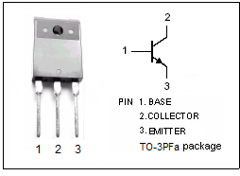

DESCRIPTION
·Low Collector Saturation Voltage
·High Collector Current
·Good Linearity of h_{FE}

APPLICATIONS
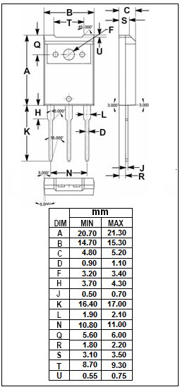
·Designed for switching regulator and high voltage
switching applications.

ABSOLUTE MAXIMUM RATINGS(T_{a}=25℃)
SYMBOL | PARAMETER | VALUE | UNIT
V_{CBO} | Collector-Base Voltage | 500 | V
V_{CEO} | Collector-Emitter Voltage | 400 | V
V_{EBO} | Emitter-Base voltage | 7 | V
I_{C} | Collector Current-Continuous | 20 | A
I_{B} | Base Current-Continuous | 6 | A
P_{C} | Collector Power Dissipation  @ T_{C}=25℃ | 125 | W
P_{C} | Collector Power Dissipation  @ T_{a}=25℃ | 3 | W
T_{J} | Junction Temperature | 150 | ℃
T_{stg} | Storage Temperature Range | -55~150 | ℃

SPTECH Silicon NPN Power Transistor 2SC3528

ELECTRICAL CHARACTERISTICS
T_{C}=25℃ unless otherwise specified
SYMBOL | PARAMETER | CONDITIONS | MIN | TYP. | MAX | UNIT
V_{CEO(SUS)} | Collector-Emitter Sustaining Voltage | I_{C}=20mA ; I_{B}=0 | 400 |  |  | V
V_{CE(sat)} | Collector-Emitter Saturation Voltage | I_{C}= 10A; I_{B}= 2A |  |  | 1.0 | V
V_{BE(sat)} | Base-Emitter Saturation Voltage | I_{C}= 10A; I_{B}= 2A |  |  | 1.5 | V
I_{CBO} | Collector Cutoff Current | V_{CB}= 500V ; I_{E}= 0 |  |  | 100 | μA
I_{EBO} | Emitter Cutoff Current | V_{EB}= 7V; I_{C}= 0 |  |  | 100 | μA
h_{FE-1} | DC Current Gain | I_{C}= 2A ; V_{CE}= 5V | 15
h_{FE-2} | DC Current Gain | I_{C}= 10A ; V_{CE}= 5V | 10
f_{T} | Current-Gain—Bandwidth Product | I_{C}= 1A ; V_{CE}= 10V; f= 1MHz |  | 15 |  | MHz
Switching times
t_{on} | Turn-On Time | I_{C}= 10A; I_{B1}= 2.0A, I_{B2}= -2.0A;  V_{CC}= 125V |  |  | 1.0 | μs
t_{stg} | Storage Time | I_{C}= 10A; I_{B1}= 2.0A, I_{B2}= -2.0A;  V_{CC}= 125V |  |  | 2.5 | μs
t_{f} | Fall Time | I_{C}= 10A; I_{B1}= 2.0A, I_{B2}= -2.0A;  V_{CC}= 125V |  |  | 1.0 | μs

