SPTECH Silicon NPN Power Transistor 2SC2625

DESCRIPTION
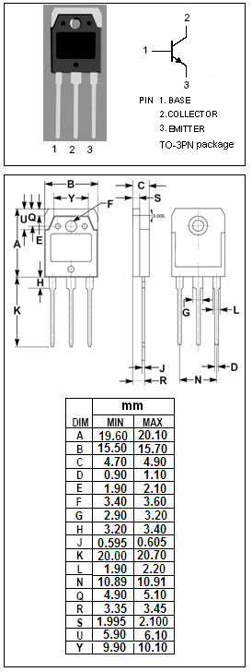
·High Collector-Emitter Breakdown Voltage-
: V_{(BR)CEO}= 400V(Min)
·High Switching Speed
·High Reliability

APPLICATIONS
·Switching regulators
·Ultrasonic generators
·High frequency inverters
·General purpose power amplifiers

ABSOLUTE MAXIMUM RATINGS(T_{a}=25℃)
SYMBOL | PARAMETER | VALUE | UNIT
V_{CBO} | Collector-Base Voltage | 450 | V
V_{CEO} | Collector-Emitter Voltage | 400 | V
V_{CEO(SUS)} | Collector-Emitter Voltage | 400 | V
V_{EBO} | Emitter-Base voltage | 7 | V
I_{C} | Collector Current-Continuous | 10 | A
I_{B} | Base Current-Continuous | 3 | A
P_{C} | Collector Power Dissipation  @ T_{C}=25℃ | 80 | W
T_{J} | Junction Temperature | 150 | ℃
T_{stg} | Storage Temperature Range | -55~150 | ℃

THERMAL CHARACTERISTICS
SYMBOL | PARAMETER | MAX | UNIT
R_{th j-c} | Thermal Resistance,Junction to Case | 1.17 | ℃/W

SPTECH Silicon NPN Power Transistor 2SC2625

ELECTRICAL CHARACTERISTICS
T_{C}=25℃ unless otherwise specified
SYMBOL | PARAMETER | CONDITIONS | MIN | TYP. | MAX | UNIT
V_{(BR)CEO} | Collector-Emitter Breakdown Voltage | I_{C}= 10mA ; I_{B}= 0 | 400 |  |  | V
V_{CEO(SUS)} | Collector-Emitter Sustaining Voltage | I_{C}= 30mA ; I_{B}= 0 | 400 |  |  | V
V_{(BR)CBO} | Collector-Base Breakdown Voltage | I_{C}= 1mA ; I_{E}= 0 | 450 |  |  | V
V_{(BR)EBO} | Emitter-Base Breakdown Voltage | I_{E}= 0.1mA ; I_{C}= 0 | 7 |  |  | V
V_{CE(sat)} | Collector-Emitter Saturation Voltage | I_{C}= 4A; I_{B}= 0.8A |  |  | 1.2 | V
V_{BE(sat)} | Base-Emitter Saturation Voltage | I_{C}= 4A; I_{B}= 0.8A |  |  | 1.5 | V
I_{CBO} | Collector Cutoff Current | V_{CB}= 450V ; I_{E}=0 |  |  | 1.0 | mA
I_{EBO} | Emitter Cutoff Current | V_{EB}= 7V; I_{C}=0 |  |  | 0.1 | mA
h_{FE} | DC Current Gain | I_{C}= 4A ; V_{CE}= 5V | 10
Switching times
t_{on} | Turn-on Time | I_{C}= 7.5A , I_{B1}= -I_{B2}= 1.5A  R_{L}= 20Ω;P_{W}=20μs  Duty Cycle≤2% |  |  | 1.0 | μs
t_{stg} | Storage Time |  |  |  | 2.0 | μs
t_{f} | Fall Time |  |  |  | 1.0 | μs

