SPTECH Silicon NPN Power Transistor 2SC3320

DESCRIPTION
·High Collector-Emitter Breakdown Voltage-
: V_{(BR)CEO}= 400V(Min)
·High Switching Speed
·High Reliability

APPLICATIONS
·Switching regulators
·Ultrasonic generators
·High frequency inverters
·General purpose power amplifiers

ABSOLUTE MAXIMUM RATINGS(T_{a}=25℃)
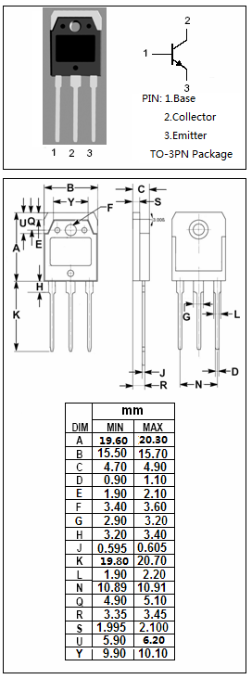
SYMBOL | PARAMETER | VALUE | UNIT
V_{CBO} | Collector-Base Voltage | 500 | V
V_{CEO} | Collector-Emitter Voltage | 400 | V
V_{CEO(SUS)} | Collector-Emitter Voltage | 400 | V
V_{EBO} | Emitter-Base Voltage | 7 | V
I_{C} | Collector Current-Continuous | 15 | A
I_{B} | Base Current-Continuous | 5 | A
P_{C} | Collector Power Dissipation  @ T_{C}=25℃ | 80 | W
T_{J} | Junction Temperature | 150 | ℃
T_{stg} | Storage Temperature Range | -65~150 | ℃

THERMAL CHARACTERISTICS
SYMBOL | PARAMETER | MAX | UNIT
R_{th j-c} | Thermal Resistance,Junction to Case | 1.56 | ℃/W

SPTECH Silicon NPN Power Transistor 2SC3320

ELECTRICAL CHARACTERISTICS
T_{C}=25℃ unless otherwise specified
SYMBOL | PARAMETER | CONDITIONS | MIN | TYP. | MAX | UNIT
V_{(BR)CEO} | Collector-Emitter Breakdown Voltage | I_{C}= 10mA ; I_{B}= 0 | 400 |  |  | V
V_{CEO(SUS)} | Collector-Emitter Sustaining Voltage | I_{C}= 50mA ; I_{B}= 0 | 400 |  |  | V
V_{(BR)CBO} | Collector-Base Breakdown Voltage | I_{C}= 1mA ; I_{E}= 0 | 500 |  |  | V
V_{(BR)EBO} | Emitter-Base Breakdown Voltage | I_{E}= 1mA ; I_{C}= 0 | 7 |  |  | V
V_{CE(sat)} | Collector-Emitter Saturation Voltage | I_{C}= 6A; I_{B}= 1.2A |  |  | 1.0 | V
V_{BE(sat)} | Base-Emitter Saturation Voltage | I_{C}= 6A; I_{B}= 1.2A |  |  | 1.5 | V
I_{CBO} | Collector Cutoff Current | V_{CB}= 500V ; I_{E}= 0 |  |  | 1.0 | mA
I_{EBO} | Emitter Cutoff Current | V_{EB}= 7V; I_{C}= 0 |  |  | 1.0 | mA
h_{FE} | DC Current Gain | I_{C}= 6A ; V_{CE}= 5V | 10
Switching times
t_{on} | Turn-on Time | I_{C}= 7.5A , I_{B1}= 1.5A; I_{B2}= -3A  R_{L}= 20Ω;P_{W}=20μs Duty≤2% |  |  | 0.5 | μs
t_{stg} | Storage Time |  |  |  | 1.5 | μs
t_{f} | Fall Time |  |  |  | 0.15 | μs

