SPTECH Silicon NPN Darlington Power Transistor MJ11032

DESCRIPTION
·Collector-Emitter Breakdown Voltage
: V_{(BR)CEO}= 120V(Min.)
·High DC Current Gain-
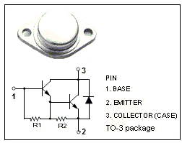
: h_{FE}= 1000(Min.)@I_{C}= 25A
: h_{FE}= 400(Min.)@I_{C}= 50A
·Complement to the PNP MJ11033

APPLICATIONS
·Designed for use as output devices in complementary
general purpose amplifier applications.

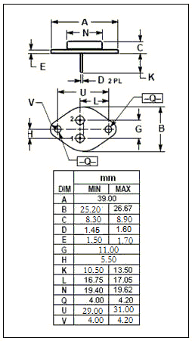
Absolute maximum ratings (T_{a}=25℃)
SYMBOL | PARAMETER | VALUE | UNIT
V_{CBO} | Collector-Base Voltage | 120 | V
V_{CEO} | Collector-Emitter Voltage | 120 | V
V_{EBO} | Emitter-Base Voltage | 5 | V
I_{C} | Collector Current-Continunous | 50 | A
I_{CM} | Collector Current-Peak | 100 | A
I_{B} | Base Current-Continunous | 2 | A
P_{C} | Collector Power Dissipation  @T_{C}=25℃ | 300 | W
T_{j} | Junction Temperature | 200 | ℃
T_{stg} | Storage Temperature Range | -55~+200 | ℃

THERMAL CHARACTERISTICS
SYMBOL | PARAMETER | MAX | UNIT
R_{th j-c} | Thermal Resistance, Junction to Case | 0.584 | ℃/W

SPTECH Silicon NPN Darlington Power Transistor MJ11032

ELECTRICAL CHARACTERISTICS
T_{C}=25℃ unless otherwise specified
SYMBOL | PARAMETER | CONDITIONS | MIN | TYP. | MAX | UNIT
V_{(BR)CEO} | Collector-Emitter Breakdown Voltage | I_{C}= 50mA; I_{B}= 0 | 120 |  |  | V
V_{CE(sat)-1} | Collector-Emitter Saturation Voltage | I_{C}= 25A; I_{B}= 250mA |  |  | 2.5 | V
V _{CE(sat)-2} | Collector-Emitter Saturation Voltage | I_{C}= 50A; I_{B}= 500mA |  |  | 3.5 | V
V_{BE(sat)-1} | Base-Emitter Saturation Voltage | I_{C}= 25A; I_{B}= 250mA |  |  | 3.0 | V
V_{BE(sat)-2} | Base-Emitter Saturation Voltage | I_{C}= 50A; I_{B}= 500mA |  |  | 4.5 | V
I_{CBO} | Collector Cutoff Current | V_{CB}=120V;I_{E}=0  V_{CB}=120V; I_{E}=0; T_{C}=150℃ |  |  | 2.0  5.0 | mA
I_{CEO} | Collector Cutoff Current | V_{CE}= 120V; I_{B}= 0 |  |  | 2.0 | mA
I_{EBO} | Emitter Cutoff Current | V_{EB}= 5V; I_{C}= 0 |  |  | 5.0 | mA
h_{FE-1} | DC Current Gain | I_{C}= 25A, V_{CE}= 5V | 1000 |  | 18000
h_{FE-2} | DC Current Gain | I_{C}= 50A, V_{CE}= 5V | 400

