SPTECH Silicon PNP Darlington Power Transistor MJ11015

DESCRIPTION
·Collector-Emitter Breakdown Voltage-
: V_{(BR)CEO}= -120V(Min.)
·High DC Current Gain-
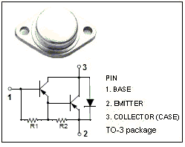
: h_{FE}= 1000(Min.)@I_{C}= -20A
·Low Collector Saturation Voltage-
: V_{CE (sat)}= -3.0V(Max.)@ I_{C}= -20A
·Complement to the NPN MJ11016

APPLICATIONS
·Designed for use as output devices in complementary
general purpose amplifier applications.
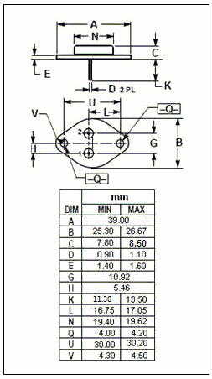

Absolute maximum ratings (T_{a}=25℃)
SYMBOL | PARAMETER | VALUE | UNIT
V_{CBO} | Collector-Base Voltage | -120 | V
V_{CEO} | Collector-Emitter Voltage | -120 | V
V_{EBO} | Emitter-Base Voltage | -5 | V
I_{C} | Collector Current-Continunous | -30 | A
I_{B} | Base Current-Continunous | -1 | A
P_{C} | Collector Power Dissipation  @T_{C}=25℃ | 200 | W
T_{j} | Junction Temperature | 200 | ℃
T_{stg} | Storage Temperature Range | -55~+200 | ℃
THERMAL CHARACTERISTICS
SYMBOL | PARAMETER | MAX | UNIT
R_{th j-c} | Thermal Resistance, Junction to Case | 0.87 | ℃/W

SPTECH Silicon PNP Darlington Power Transistor MJ11015

ELECTRICAL CHARACTERISTICS
T_{C}=25℃ unless otherwise specified
SYMBOL | PARAMETER | CONDITIONS | MIN | TYP. | MAX | UNIT
V_{(BR)CEO} | Collector-Emitter Breakdown Voltage | I_{C}= -50mA; I_{B}= 0 | -120 |  |  | V
V_{CE(sat)-1} | Collector-Emitter Saturation Voltage | I_{C}= -20A; I_{B}= -0.2A |  |  | -3.0 | V
V _{CE(sat)-2} | Collector-Emitter Saturation Voltage | I_{C}= -30A; I_{B}= -0.3A |  |  | -4.0 | V
V_{BE(sat)-1} | Base-Emitter Saturation Voltage | I_{C}= -20A; I_{B}= -0.2A |  |  | -3.5 | V
V_{BE(sat)-2} | Base-Emitter Saturation Voltage | I_{C}= -30A; I_{B}= -0.3A |  |  | -5.0 | V
I_{CBO} | Collector Cutoff Current | V_{CB}=-120V; I_{E}=0  V_{CB}=-120V; I_{E}=0; T_{C}=150℃ |  |  | -1.0  -5.0 | mA
I_{CEO} | Collector Cutoff Current | V_{CE}= -120V; I_{B}= 0 |  |  | -1.0 | mA
I_{EBO} | Emitter Cutoff Current | V_{EB}= -5V; I_{C}= 0 |  |  | -5.0 | mA
h_{FE-1} | DC Current Gain | I_{C}= -20A, V_{CE}= -5V | 1000
h_{FE-2} | DC Current Gain | I_{C}= -30A, V_{CE}= -5V | 200

