SPTECH Silicon NPN Darlington Power Transistor 2SD1525

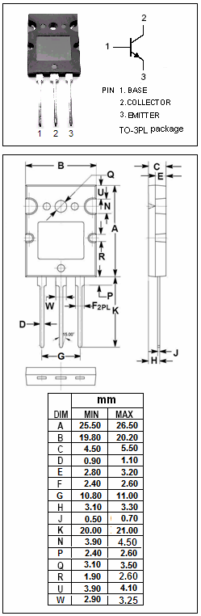
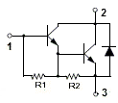

DESCRIPTION
·High DC Current Gain
: h_{FE}= 1000(Min.)@ I_{C}= 20A
·Collector-Emitter Breakdown Voltage-
: V_{(BR)CEO} = 100V(Min.)

APPLICATIONS
·Designed for high current switching applications.

ABSOLUTE MAXIMUM RATINGS(T_{a}=25℃)
SYMBOL | PARAMETER | VALUE | UNIT
V_{CBO} | Collector-Base Voltage | 100 | V
V_{CEO} | Collector-Emitter Voltage | 100 | V
V_{EBO} | Emitter-Base Voltage | 5 | V
I_{C} | Collector Current-Continuous | 30 | A
I_{B} | Base Current- Continuous | 5 | A
P_{C} | Collector Power Dissipation  @T_{C}=25℃ | 150 | W
T_{j} | Junction Temperature | 150 | ℃
T_{stg} | Storage Temperature Range | -55~150 | ℃

SPTECH Silicon NPN Darlington Power Transistor 2SD1525

ELECTRICAL CHARACTERISTICS
T_{C}=25℃ unless otherwise specified
SYMBOL | PARAMETER | CONDITIONS | MIN | TYP. | MAX | UNIT
V_{(BR)CEO} | Collector-Emitter Breakdown Voltage | I_{C}= 30mA, I_{B}= 0 | 100 |  |  | V
V_{CE(sat)} | Collector-Emitter Saturation Voltage | I_{C}= 20A, I_{B}= 0.2A |  |  | 1.5 | V
V_{BE(sat)} | Base-Emitter Saturation Voltage | I_{C}= 20A, I_{B}= 0.2A |  |  | 2.5 | V
I_{CBO} | Collector Cutoff current | V_{CB}= 100V, I_{E}= 0 |  |  | 0.1 | mA
I_{EBO} | Emitter Cutoff current | V_{EB}= 5V, I_{C}= 0 |  |  | 10 | mA
h_{FE-1} | DC Current Gain | I_{C}= 20A; V_{CE}= 5V | 1000
h_{FE-2} | DC Current Gain | I_{C}= 30A; V_{CE}= 5V | 200
V_{ECF} | C-E Diode Forward Voltage | I_{F}= 10A |  |  | 3.0 | V
f_{T} | Current-Gain—Bandwidth Product | I_{C}= 1A; V_{CE}= 5V |  | 10 |  | MHz
C_{OB} | Output Capacitance | I_{E}= 0; V_{CB}= 10V; f_{test}= 1MHz |  | 500 |  | pF
Switching Times
t_{on} | Turn-On Time | I_{B1} = I_{B2}= 10mA; V_{CC}= 50V;  R_{L}= 10Ω |  | 1.5 |  | μs
t_{stg} | Storage Time | I_{B1} = I_{B2}= 10mA; V_{CC}= 50V;  R_{L}= 10Ω |  | 10 |  | μs
t_{f} | Fall Time | I_{B1} = I_{B2}= 10mA; V_{CC}= 50V;  R_{L}= 10Ω |  | 1.5 |  | μs

