SPTECH Silicon NPN Power Transistor BU941P

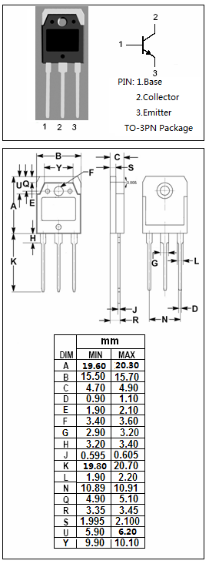
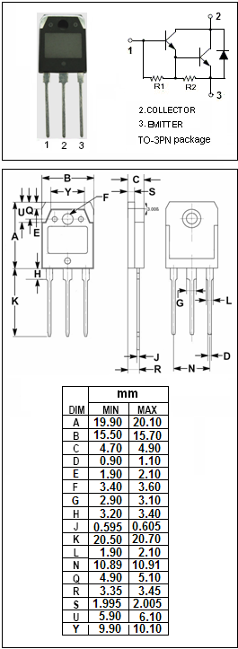

DESCRIPTION
·High Voltage
·DARLINGTON

APPLICATIONS
·High ruggedness electronic ignitions
·High voltage ignition coil driver

Absolute maximum ratings (TB_{aB}=25℃)
SYMBOL | PARAMETER | VALUE | UNIT
VB_{CBOB} | Collector-Base Voltage | 500 | V
VB_{CEOB} | Collector-Emitter Voltage | 400 | V
VB_{EBOB} | Emitter-Base Voltage | 5 | V
IB_{CB} | Collector Current- Continuous | 15 | A
IB_{CMB} | Collector Current-Peak | 30 | A
IB_{BB} | Base Current | 1 | A
IB_{BMB} | Base Current-Peak | 5 | A
PB_{CB} | Collector Power Dissipation  @TB_{CB}=25℃ | 155 | W
TB_{jB} | Junction Temperature | 150 | ℃
TB_{stgB} | Storage Temperature Range | -65~150 | ℃

THERMAL CHARACTERISTICS
SYMBOL | PARAMETER | MAX | UNIT
RB_{th j-cB} | Thermal Resistance, Junction to Case | 0.97 | ℃/W

SPTECH Silicon NPN Power Transistor BU941P

ELECTRICAL CHARACTERISTICS
TB_{CB}=25℃ unless otherwise specified
SYMBOL | PARAMETER | CONDITIONS | MIN | TYP | MAX | UNIT
VB_{CEO(SUS)B} | Collector-Emitter Sustaining Voltage | IB_{CB}=50mA; IB_{BB}= 0 | 400 |  |  | V
VB_{CE(sat)-1B} | Collector-Emitter Saturation Voltage | IB_{CB}= 8 A; IB_{BB}= 100mA |  |  | 1.6 | V
VB_{CE(sat)-2B} | Collector-Emitter Saturation Voltage | IB_{CB}= 10 A; IB_{BB}= 250mA |  |  | 1.8 | V
VB_{CE(sat)-3B} | Collector-Emitter Saturation Voltage | IB_{CB}= 12 A; IB_{BB}= 300mA |  |  | 2.0 | V
VB_{BE(sat)-1B} | Base-Emitter Saturation Voltage | IB_{CB}= 8 A; IB_{BB}= 100mA |  |  | 2.2 | V
VB_{BE(sat)-2B} | Base-Emitter Saturation Voltage | IB_{CB}= 10 A; IB_{BB}= 250mA |  |  | 2.5 | V
VB_{BE(sat)-3B} | Base-Emitter Saturation Voltage | IB_{CB}= 12 A; IB_{BB}= 300mA |  |  | 2.7 | V
IB_{CESB} | Collector Cutoff Current | VB_{CEB}= 500V;VB_{BEB}= 0  VB_{CEB}= 500V;VB_{BEB}= 0;TB_{jB}= 125℃ |  |  | 0.1  0.5 | mA
IB_{CEOB} | Collector Cutoff Current | VB_{CEB}= 450V; IB_{BB}= 0  VB_{CEB}= 450V; IB_{BB}= 0;TB_{jB}= 125℃ |  |  | 0.1  0.5 | mA
IB_{EBOB} | Emitter Cutoff Current | VB_{EBB}= 5V; IB_{CB}= 0 |  |  | 20 | mA
hB_{FEB} | DC Current Gain | IB_{CB}= 5A ; VB_{CEB}= 10V | 300
VB_{ECFB} | C-E Diode Forward Voltage | IB_{FB}= 10A |  |  | 2.5 | V

