SPTECH Silicon NPN Power Transistor BU941T

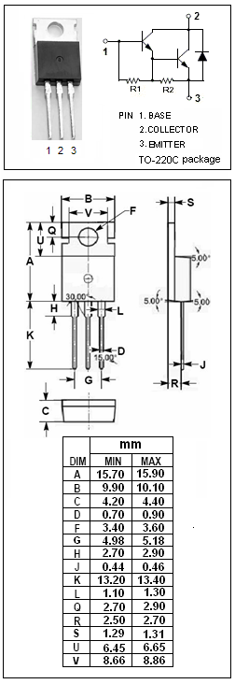
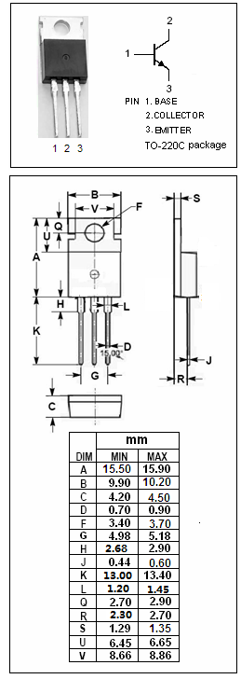

DESCRIPTION
·High Voltage
·DARLINGTON

APPLICATIONS
·High ruggedness electronic ignitions
·High voltage ignition coil driver

Absolute maximum ratings (T_{a}=25℃)
SYMBOL | PARAMETER | VALUE | UNIT
V_{CBO} | Collector-Base Voltage | 500 | V
V_{CEO} | Collector-Emitter Voltage | 400 | V
V_{EBO} | Emitter-Base Voltage | 5 | V
I_{C} | Collector Current- Continuous | 15 | A
I_{CM} | Collector Current-Peak | 30 | A
I_{B} | Base Current | 1 | A
I_{BM} | Base Current-Peak | 5 | A
P_{C} | Collector Power Dissipation  @T_{C}=25℃ | 150 | W
T_{j} | Junction Temperature | 150 | ℃
T_{stg} | Storage Temperature Range | -65~150 | ℃

THERMAL CHARACTERISTICS
SYMBOL | PARAMETER | MAX | UNIT
R_{th j-c} | Thermal Resistance, Junction to Case | 1.2 | ℃/W

SPTECH Silicon NPN Power Transistor BU941T

ELECTRICAL CHARACTERISTICS
T_{C}=25℃ unless otherwise specified
SYMBOL | PARAMETER | CONDITIONS | MIN | TYP | MAX | UNIT
V_{CEO(SUS)} | Collector-Emitter Sustaining Voltage | I_{C}= 50mA; I_{B}= 0 | 400 |  |  | V
V_{CE(sat)-1} | Collector-Emitter Saturation Voltage | I_{C}= 8 A; I_{B}= 100mA |  |  | 1.6 | V
V_{CE(sat)-2} | Collector-Emitter Saturation Voltage | I_{C}= 10 A; I_{B}= 250mA |  |  | 1.8 | V
V_{CE(sat)-3} | Collector-Emitter Saturation Voltage | I_{C}= 12 A; I_{B}= 300mA |  |  | 2.0 | V
V_{BE(sat)-1} | Base-Emitter Saturation Voltage | I_{C}= 8 A; I_{B}= 100mA |  |  | 2.2 | V
V_{BE(sat)-2} | Base-Emitter Saturation Voltage | I_{C}= 10 A; I_{B}= 250mA |  |  | 2.5 | V
V_{BE(sat)-3} | Base-Emitter Saturation Voltage | I_{C}= 12 A; I_{B}= 300mA |  |  | 2.7 | V
I_{CES} | Collector Cutoff Current | V_{CE}= 500V;V_{BE}= 0  V_{CE}= 500V;V_{BE}= 0;T_{j}=125℃ |  |  | 0.1  0.5 | mA
I_{CEO} | Collector Cutoff Current | V_{CE}= 450V;I_{B}= 0  V_{CE}= 450V;I_{B}= 0;T_{j}= 125℃ |  |  | 0.1  0.5 | mA
I_{EBO} | Emitter Cutoff Current | V_{EB}= 5V; I_{C}= 0 |  |  | 20 | mA
h_{FE} | DC Current Gain | I_{C}= 5A ; V_{CE}= 10V | 300
V_{ECF} | C-E Diode Forward Voltage | I_{F}= 10A |  |  | 2.5 | V

