SPTECH Silicon NPN Darlington Power Transistor 2SD1071

DESCRIPTION
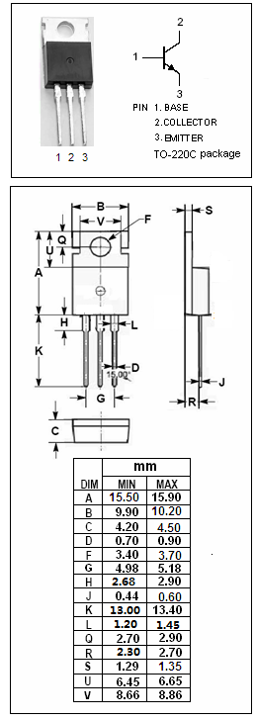
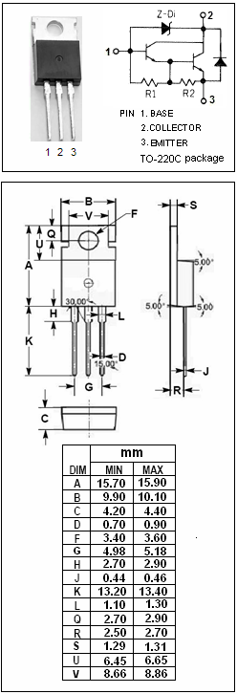
·Low Collector Saturation Voltage
·High DC Current Gain
·High Reliability

APPLICATIONS
·Audio power amplifiers
·Relay & solenoid drivers
·Motor controls
·General purpose power amplifiers
·Including zener diode

ABSOLUTE MAXIMUM RATINGS(T_{a}=25℃)
SYMBOL | PARAMETER | VALUE | UNIT
V_{CBO} | Collector-Base Voltage | 450 | V
V_{CEO(SUS)} | Collector-Emitter Voltage | 300 | V
V_{EBO} | Emitter-Base Voltage | 6 | V
V_{Z} | Zener Voltage | 300 | V
I_{C} | Collector Current-Continuous | 6 | A
I_{B} | Base Current-Continuous | 2.5 | A
P_{C} | Collector Power Dissipation  @ T_{C}=25℃ | 40 | W
T_{J} | Junction Temperature | 150 | ℃
T_{stg} | Storage Temperature Range | -40~150 | ℃

THERMAL CHARACTERISTICS
SYMBOL | PARAMETER | MAX | UNIT
R_{th j-c} | Thermal Resistance,Junction to Case | 3.0 | ℃/W

SPTECH Silicon NPN Darlington Power Transistor 2SD1071

ELECTRICAL CHARACTERISTICS
T_{C}=25℃ unless otherwise specified
SYMBOL | PARAMETER | CONDITIONS | MIN | TYP. | MAX | UNIT
V_{Z} | Zener Voltage | I_{Z}= 0.1mA | 300 |  | 450 | V
V_{(BR)EBO} | Emitter-Base Breakdown Voltage | I_{E}= 5mA; I_{C}= 0 | 6 |  |  | V
V_{CE(sat)} | Collector-Emitter Saturation Voltage | I_{C}= 4A; I_{B}= 15mA |  |  | 1.5 | V
V_{BE(sat)} | Base-Emitter Saturation Voltage | I_{C}= 4A; I_{B}= 15mA |  |  | 2.0 | V
I_{CBO} | Collector Cutoff Current | V_{CB}= 300V; I_{E}= 0 |  |  | 0.1 | mA
I_{EBO} | Emitter Cutoff Current | V_{EB}= 6V; I_{C}=0 |  |  | 5 | mA
h_{FE} | DC Current Gain | I_{C}= 4A; V_{CE}= 2V | 500

