SPTECH Silicon NPN Power Transistor 2SC3907

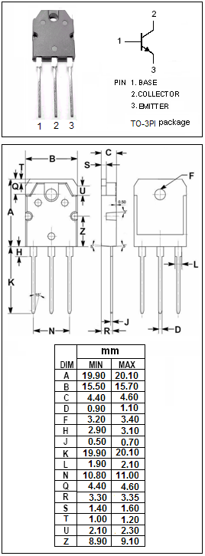

DESCRIPTION
·Collector-Emitter Breakdown Voltage-
: V_{(BR)CEO}= 180V(Min)
·Good Linearity of h_{FE}
·Complement to Type 2SA1516

APPLICATIONS
·Power amplifier applications
·Recommend for 80W high fidelity audio frequency
amplifier output stage applications

ABSOLUTE MAXIMUM RATINGS(T_{a}=25℃)
SYMBOL | PARAMETER | VALUE | UNIT
V_{CBO} | Collector-Base Voltage | 180 | V
V_{CEO} | Collector-Emitter Voltage | 180 | V
V_{EBO} | Emitter-Base Voltage | 5 | V
I_{C} | Collector Current-Continuous | 12 | A
I_{B} | Base Current-Continuous | 1.2 | A
P_{C} | Collector Power Dissipation  @ T_{C}=25℃ | 130 | W
T_{J} | Junction Temperature | 150 | ℃
T_{stg} | Storage Temperature Range | -55~150 | ℃

SPTECH Silicon NPN Power Transistor 2SC3907

ELECTRICAL CHARACTERISTICS
T_{C}=25℃ unless otherwise specified
SYMBOL | PARAMETER | CONDITIONS | MIN | TYP. | MAX | UNIT
V_{(BR)CEO} | Collector-Emitter Breakdown Voltage | I_{C}= 50mA; I_{B}= 0 | 180 |  |  | V
V_{CE(sat)} | Collector-Emitter Saturation Voltage | I_{C}= 8A; I_{B}= 0.8A |  |  | 2.0 | V
V_{BE(on)} | Base-Emitter On Voltage | I_{C}= 7A ; V_{CE}= 5V |  |  | 1.5 | V
I_{CBO} | Collector Cutoff Current | V_{CB}= 180V; I_{E}= 0 |  |  | 5 | μA
I_{EBO} | Emitter Cutoff Current | V_{EB}= 5V; I_{C}= 0 |  |  | 5 | μA
h_{FE-1} | DC Current Gain | I_{C}= 1A; V_{CE}= 5V | 55 |  | 180
h_{FE-2} | DC Current Gain | I_{C}= 7A; V_{CE}= 5V | 35
C_{OB} | Output Capacitance | I_{E}=0; V_{CB}= 10V;f_{test}= 1.0MHz |  | 270 |  | pF
f_{T} | Current-Gain—Bandwidth Product | I_{C}= 1A; V_{CE}= 5V |  | 30 |  | MHz

- h_{FE-1} Classifications
R | O
55-110 | 90-180

