SPTECH Silicon NPN Power Transistor 2SC4110

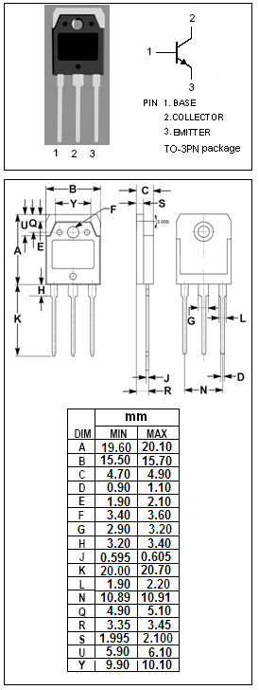

DESCRIPTION
·High Collector-Emitter Breakdown Voltage-
: V_{(BR)CEO}= 400V(Min)
·High Switching Speed
·Wide Area of Safe Operation

APPLICATIONS
·Designed for switching regulator and general purpose
applications.

ABSOLUTE MAXIMUM RATINGS(T_{a}=25℃)
SYMBOL | PARAMETER | VALUE | UNIT
V_{CBO} | Collector-Base Voltage | 500 | V
V_{CEO} | Collector-Emitter Voltage | 400 | V
V_{EBO} | Emitter-Base voltage | 7 | V
I_{C} | Collector Current-Continuous | 25 | A
I_{CM} | Collector Current-Peak PW≤300μs, duty cycle≤10% | 40 | A
I_{B} | Base Current-Continuous | 8 | A
P_{C} | Collector Power Dissipation  @ T_{C}=25℃ | 160 | W
P_{C} | Collector Power Dissipation  @ T_{a}=25℃ | 2.5 | W
T_{J} | Junction Temperature | 150 | ℃
T_{stg} | Storage Temperature Range | -55~150 | ℃

SPTECH Silicon NPN Power Transistor 2SC4110

ELECTRICAL CHARACTERISTICS
T_{C}=25℃ unless otherwise specified
SYMBOL | PARAMETER | CONDITIONS | MIN | TYP. | MAX | UNIT
V_{(BR)CBO} | Collector-Base Breakdown Voltage | I_{C}= 1mA; I_{E}= 0 | 500 |  |  | V
V_{(BR)CEO} | Collector-Emitter Breakdown Voltage | I_{C}= 10mA; R_{BE}= ∞ | 400 |  |  | V
V_{(BR)EBO} | Emitter-Base Breakdown Voltage | I_{E}= 1m A; I_{C}= 0 | 7 |  |  | V
V_{CE(sat)} | Collector-Emitter Saturation Voltage | I_{C}= 16A; I_{B}= 3.2A |  |  | 0.8 | V
V_{BE(sat)} | Base-Emitter Saturation Voltage | I_{C}= 16A; I_{B}= 3.2A |  |  | 1.5 | V
I_{CBO} | Collector Cutoff Current | V_{CB}= 400V ; I_{E}= 0 |  |  | 10 | μA
I_{EBO} | Emitter Cutoff Current | V_{EB}= 5V; I_{C}= 0 |  |  | 10 | μA
h_{FE-1} | DC Current Gain | I_{C}= 3.2A ; V_{CE}= 5V | 15 |  | 50
h_{FE-2} | DC Current Gain | I_{C}= 16A ; V_{CE}= 5V | 10
h_{FE-3} | DC Current Gain | I_{C}= 10mA ; V_{CE}= 5V | 10
f_{T} | Current-Gain—Bandwidth Product | I_{C}= 3.2A ; V_{CE}= 10V |  | 20 |  | MHz
C_{OB} | Output Capacitance | I_{E}= 0; V_{CB}= 10V; f_{test}= 1.0MHz |  | 300 |  | pF
Switching Times
t_{on} | Turn-on Time | I_{C}= 20A, I_{B1}= 4A; I_{B2}= -8A  R_{L}= 10Ω; V_{CC}= 200V |  |  | 0.5 | μs
t_{stg} | Storage Time |  |  |  | 2.5 | μs
t_{f} | Fall Time |  |  |  | 0.3 | μs

- h_{FE-1} Classifications
L | M | N
15-30 | 20-40 | 30-50

