isc Silicon NPN Power Transistor 2SC4550

DESCRIPTION
·Collector-Emitter Sustaining Voltage-
: V_{CEO(SUS)}= 60V(Min)
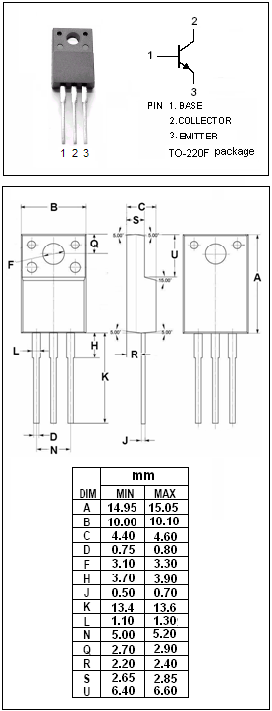
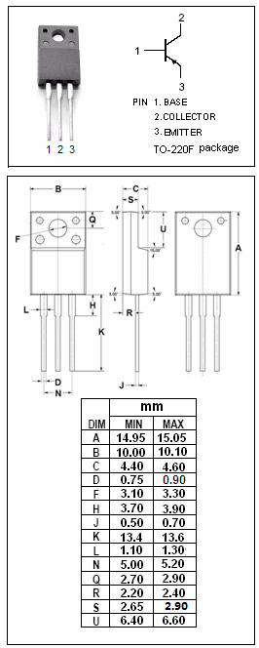
·High DC Current Gain-
: h_{FE}= 100(Min)@ (V_{CE}= 2V , I_{C}= 1.5A)
·Low Saturation Voltage-
: V_{CE(sat)}= 0.3V(Max)@ (I_{C}= 4A, I_{B}= 0.2A)

APPLICATIONS
·Designed for use as a driver in DC/DC converters and
actuators.

ABSOLUTE MAXIMUM RATINGS(T_{a}=25℃)
SYMBOL | PARAMETER | VALUE | UNIT
V_{CBO} | Collector-Base Voltage | 100 | V
V_{CEO} | Collector-Emitter Voltage | 60 | V
V_{EBO} | Emitter-Base Voltage | 7.0 | V
I_{C} | Collector Current-Continuous | 7.0 | A
I_{CM} | Collector Current-Pulse | 14 | A
I_{B} | Base Current-Continuous | 3.5 | A
P_{T} | Total Power Dissipation @T_{C}=25℃ | 30 | W
P_{T} | Total Power Dissipation @T_{a}=25℃ | 2.0 | W
T_{J} | Junction Temperature | 150 | ℃
T_{stg} | Storage Temperature | -55~150 | ℃

SPTECH Silicon NPN Power Transistor 2SC4550

ELECTRICAL CHARACTERISTICS
Tj=25℃ unless otherwise specified
SYMBOL | PARAMETER | CONDITIONS | MIN | TYP. | MAX | UNIT
V_{CEO(SUS)} | Collector-Emitter Sustaining Voltage | I_{C}=50mA,Ib=0 | 60 |  |  | V
V_{CE(sat)-1} | Collector-Emitter Saturation Voltage | I_{C}= 4A; I_{B}= 0.2A |  |  | 0.3 | V
V_{CE(sat)-2} | Collector-Emitter Saturation Voltage | I_{C}= 6A; I_{B}= 0.3A |  |  | 0.5 | V
V_{BE(sat)-1} | Base-Emitter Saturation Voltage | I_{C}= 4A; I_{B}= 0.2A |  |  | 1.2 | V
V_{BE(sat)-2} | Base-Emitter Saturation Voltage | I_{C}= 6A; I_{B}= 0.3A |  |  | 1.5 | V
I_{CBO} | Collector Cutoff Current | V_{CB}= 60V ; I_{E}= 0 |  |  | 10 | μA
I_{CER} | Collector Cutoff Current | V_{CE}= 60V ; R_{BE}= 50Ω,T_{a}=125℃ |  |  | 1.0 | mA
I_{EBO} | Emitter Cutoff Current | V_{EB}= 5V; I_{C}= 0 |  |  | 10 | μA
h_{FE-1} | DC Current Gain | I_{C}= 0.7A ; V_{CE}= 2V | 100
h_{FE-2} | DC Current Gain | I_{C}= 1.5A ; V_{CE}= 2V | 100 |  | 400
h_{FE-3} | DC Current Gain | I_{C}= 4.0A ; V_{CE}= 2V | 60
C_{OB} | Output Capacitance | I_{E}= 0 ; V_{CB}= 10V; f= 1.0MHz |  | 100 |  | pF
f_{T} | Current-Gain—Bandwidth Product | I_{C}= 1A ; V_{CE}= 10V | 30 |  |  | MHz
Switching times
t_{on} | Turn-on Time | I_{C}= 4.0A ,R_{L}= 12.5Ω,  I_{B1}= -I_{B2}= 0.2A,V_{CC}≈ 50V |  |  | 0.3 | μs
t_{stg} | Storage Time |  |  |  | 1.5 | μs
t_{f} | Fall Time |  |  |  | 0.3 | μs

- h_{FE-2} Classifications
M | L | K
100-200 | 150-300 | 200-400

