SPTECH Silicon PNP Power Transistor 2SA1744

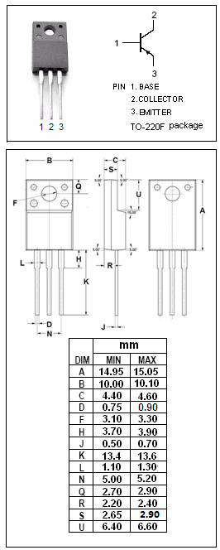

DESCRIPTION
·Collector-Emitter Sustaining Voltage-
: V_{CEO(SUS)}= -60V(Min)
·High DC Current Gain-
: h_{FE}= 100(Min)@ (V_{CE}= -2V , I_{C}= -3A)
·Low Saturation Voltage-
: V_{CE(sat)}= -0.3V(Max)@ (I_{C}= -8A, I_{B}= -0.4A)

APPLICATIONS
·This type of power transistor is developed for high-speed
switching and features a high h_{FE} at low V_{CE(sat)},which is
ideal for use as a driver in DC/DC converters and actuators.

ABSOLUTE MAXIMUM RATINGS(T_{a}=25℃)
SYMBOL | PARAMETER | VALUE | UNIT
V_{CBO} | Collector-Base Voltage | -100 | V
V_{CEO} | Collector-Emitter Voltage | -60 | V
V_{EBO} | Emitter-Base Voltage | -7.0 | V
I_{C} | Collector Current-Continuous | -15 | A
I_{CM} | Collector Current-Pulse | -30 | A
I_{B} | Base Current-Continuous | -7.5 | A
P_{T} | Total Power Dissipation @T_{C}=25℃ | 30 | W
P_{T} | Total Power Dissipation @T_{a}=25℃ | 2.0 | W
T_{J} | Junction Temperature | 150 | ℃
T_{stg} | Storage Temperature | -55~150 | ℃

SPTECH Silicon PNP Power Transistor 2SA1744

ELECTRICAL CHARACTERISTICS
Tj=25℃ unless otherwise specified
SYMBOL | PARAMETER | CONDITIONS | MIN | TYP. | MAX | UNIT
V_{CEO(SUS)} | Collector-Emitter Sustaining Voltage | I_{C}= -8.0A ; I_{B}= -0.8A, L= 1mH | -60 |  |  | V
V_{CEX(SUS)} | Collector-Emitter Sustaining Voltage | I_{C}= -8.0A ; I_{B1}=-I_{B2}= -0.8A,  V_{BE(OFF)}=1.5V, L=180μH,clamped | -60 |  |  | V
V_{CE(sat)-1} | Collector-Emitter Saturation Voltage | I_{C}= -8A; I_{B}= -0.4A |  |  | -0.3 | V
V_{CE(sat)-2} | Collector-Emitter Saturation Voltage | I_{C}= -12A; I_{B}= -0.6A |  |  | -0.5 | V
V_{BE(sat)-1} | Base-Emitter Saturation Voltage | I_{C}= -8A; I_{B}= -0.4A |  |  | -1.2 | V
V_{BE(sat)-2} | Base-Emitter Saturation Voltage | I_{C}= -12A; I_{B}= -0.6A |  |  | -1.5 | V
I_{CBO} | Collector Cutoff Current | V_{CB}= -60V ; I_{E}=0 |  |  | -10 | μA
I_{CER} | Collector Cutoff Current | V_{CE}= -60V ; R_{BE}= 50Ω,T_{a}=125℃ |  |  | -1.0 | mA
I_{CEX} | Collector Cutoff Current | V_{CE}= -60V; V_{BE(off)}= -1.5V  V_{CE}= -60V; V_{BE(off)}= -1.5V,T_{a}=125℃ |  |  | -10  -1.0 | μA  mA
I_{EBO} | Emitter Cutoff Current | V_{EB}= -5V; I_{C}=0 |  |  | -10 | μA
h_{FE-1} | DC Current Gain | I_{C}= -1.5A; V_{CE}= -2V | 100
h_{FE-2} | DC Current Gain | I_{C}= -3.0A; V_{CE}= -2V | 100 |  | 400
h_{FE-3} | DC Current Gain | I_{C}= -8.0A; V_{CE}= -2V | 60
C_{OB} | Output Capacitance | I_{E}=0; V_{CB}= -10V; f= 1.0MHz |  | 300 |  | pF
f_{T} | Current-Gain—Bandwidth Product | I_{C}= -1.5A; V_{CE}= -10V |  | 80 |  | MHz
Switching times
t_{on} | Turn-on Time | I_{C}= -8.0A, R_{L}= 6.3Ω,  I_{B1}= -I_{B2}= -0.4A, V_{CC}≈ -50V |  |  | 0.3 | μs
t_{stg} | Storage Time |  |  |  | 1.5 | μs
t_{f} | Fall Time |  |  |  | 0.3 | μs

- h_{FE-2} Classifications
M | L | K
100-200 | 150-300 | 200-400

