SPTECH Silicon NPN Power Transistor 2SC3058

DESCRIPTION
·High Collector-Emitter Sustaining Voltage-
: V_{CEO(sus)}= 400V(Min)
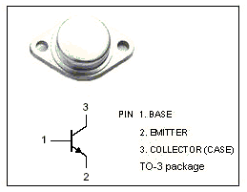
·High Switching Speed
·Wide Area of Safe Operation

APPLICATIONS
·Switching regulators
·Motor controls
·Ultrasonic generators
·Class C and D amplifiers
·Deflection circuits
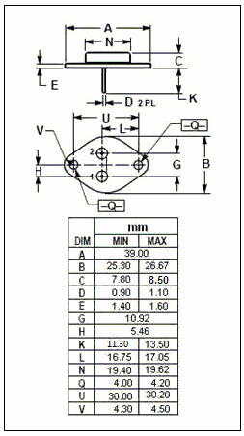

ABSOLUTE MAXIMUM RATINGS(T_{a}=25℃)
SYMBOL | PARAMETER | VALUE | UNIT
V_{CBO} | Collector-Base Voltage | 600 | V
V_{CEO} | Collector-Emitter Voltage | 400 | V
V_{EBO} | Emitter-Base voltage | 7 | V
I_{C} | Collector Current-Continuous | 30 | A
I_{CM} | Collector Current-Peak | 50 | A
I_{B} | Base Current-Continuous | 10 | A
P_{C} | Collector Power Dissipation  @ T_{C}=25℃ | 200 | W
T_{J} | Junction Temperature | 175 | ℃
T_{stg} | Storage Temperature Range | -65~175 | ℃

SPTECH Silicon NPN Power Transistor 2SC3058

ELECTRICAL CHARACTERISTICS
T_{C}=25℃ unless otherwise specified
SYMBOL | PARAMETER | CONDITIONS | MIN | TYP. | MAX | UNIT
V_{CEO(SUS)} | Collector-Emitter Sustaining Voltage | I_{C}= 30mA; R_{BE}= ∞ | 400 |  |  | V
V_{(BR)CBO} | Collector-Base Breakdown Voltage | I_{C}= 1 mA; I_{E}= 0 | 600 |  |  | V
V_{(BR)EBO} | Emitter-Base Breakdown Voltage | I_{E}= 1mA; I_{C}= 0 | 7 |  |  | V
V_{CE(sat)} | Collector-Emitter Saturation Voltage | I_{C}= 20A; I_{B}= 4A |  |  | 1.0 | V
V_{BE(sat)} | Base-Emitter Saturation Voltage | I_{C}= 20A; I_{B}= 4A |  |  | 1.5 | V
I_{CBO} | Collector Cutoff Current | V_{CB}= 500V; I_{E}= 0  V_{CB}= 500V; I_{E}= 0; T_{C}= 100℃ |  |  | 0.1  2.0 | mA
I_{EBO} | Emitter Cutoff Current | V_{EB}= 6V; I_{C}= 0 |  |  | 100 | μA
h_{FE} | DC Current Gain | I_{C}= 20A; V_{CE}= 5V | 10 |  | 40
f_{T} | Current-Gain—Bandwidth Product | I_{C}= 4A; V_{CE}= 10V | 15 |  |  | MHz
C_{OB} | Output Capacitance | I_{E}= 0; V_{CB}= 10V; f_{test}= 1.0MHz |  | 420 |  | pF
Switching times
t_{r} | Rise Time | I_{C}= 20A, I_{B1}= -I_{B2}= 4A; V_{CC}= 150V |  |  | 0.5 | μs
t_{stg} | Storage Time | I_{C}= 20A, I_{B1}= -I_{B2}= 4A; V_{CC}= 150V |  |  | 3.0 | μs
t_{f} | Fall Time | I_{C}= 20A, I_{B1}= -I_{B2}= 4A; V_{CC}= 150V |  |  | 0.3 | μs

