SPTECH Silicon NPN Power Transistor 2SC4237

DESCRIPTION
·Collector-Emitter Sustaining Voltage-
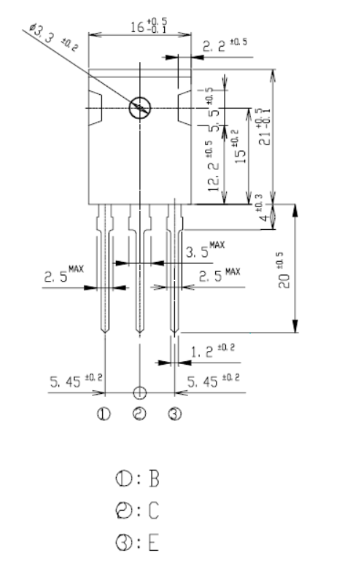
: V_{CEO(SUS)}= 800V(Min)
·Fast Switching speed

APPLICATIONS
·Color TV horizontal output applications

ABSOLUTE MAXIMUM RATINGS(Ta=25℃)
SYMBOL | PARAMETER | VALUE | UNIT
V_{CBO} | Collector-Base Voltage | 1200 | V
V_{CEO} | Collector-Emitter Voltage | 800 | V
V_{EBO} | Emitter-Base Voltage | 7 | V
I_{C} | Collector Current-Continuous | 12 | A
I_{CM} | Collector Current-Peak | 25 | A
I_{B} | Base Current-Continuous | 4 | A
I_{BM} | Base Current-Peak | 8 | 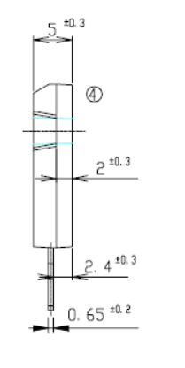  A
P_{T} | Total Power Dissipation  @ T_{C}=25℃ | 150 | W
T_{J} | Junction Temperature | 150 | ℃
T_{stg} | Storage Temperature Range | -55~150 | ℃

THERMAL CHARACTERISTICS
SYMBOL | PARAMETER | MAX | UNIT
R_{th j-c} | Thermal Resistance,Junction to Case | 0.83 | ℃/W

SPTECH Silicon NPN Power Transistor 2SC4237

ELECTRICAL CHARACTERISTICS
T_{C}=25℃ unless otherwise specified
SYMBOL | PARAMETER | CONDITIONS | MIN | TYP. | MAX | UNIT
V_{CEO(SUS)} | Collector-Emitter Sustaining Voltage | I_{C}= 10mA; I_{B}= 0 | 800 |  |  | V
V_{CE(sat)} | Collector-Emitter Saturation Voltage | I_{C}= 5A; I_{B}= 1A |  |  | 1.0 | V
V_{BE(sat)} | Base-Emitter Saturation Voltage | I_{C}= 5A; I_{B}= 1A |  |  | 1.5 | V
I_{CBO} | Collector Cutoff Current | At rated Voltage |  |  | 100 | μA
I_{CEO} | Collector Cutoff Current | At rated Voltage |  |  | 100 | μA
I_{EBO} | Emitter Cutoff Current | At rated Voltage |  |  | 100 | μA
h_{FE-1} | DC Current Gain | I_{C}= 5A ; V_{CE}= 5V | 18 |  | 28
h_{FE-2} | DC Current Gain | I_{C}= 1mA ; V_{CE}= 5V | 5
f_{T} | Current-Gain—Bandwidth Product | I_{C}= 1A ; V_{CE}= 10V |  | 8 |  | MHz
Switching times
t_{on} | Turn-on Time | I_{C}= 5A , I_{B1}= 1A; I_{B2}= -2A  R_{L}= 50Ω; V_{BB2}= 4V |  |  | 0.5 | μs
t_{stg} | Storage Time | I_{C}= 5A , I_{B1}= 1A; I_{B2}= -2A  R_{L}= 50Ω; V_{BB2}= 4V |  |  | 3.5 | μs
t_{f} | Fall Time | I_{C}= 5A , I_{B1}= 1A; I_{B2}= -2A  R_{L}= 50Ω; V_{BB2}= 4V |  |  | 0.3 | μs

