SPTECH Silicon PNP Power Transistor 2SA1943

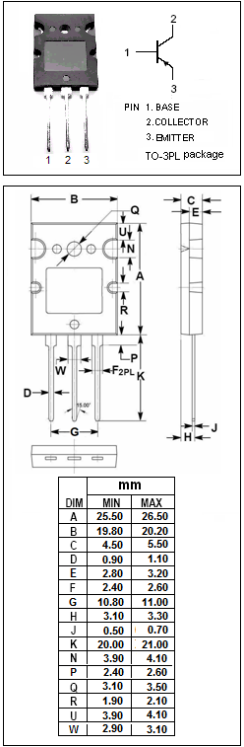
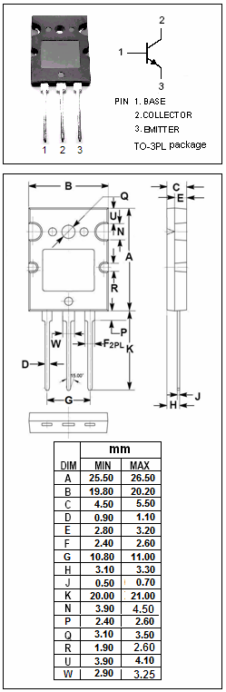

DESCRIPTION
·High Collector-Emitter Breakdown Voltage-
: V_{(BR)CEO}= -230V(Min)
·Complement to Type 2SC5200

APPLICATIONS
·Power amplifier applications
·Recommended for 100W high fidelity audio frequency amplifier
output stage

ABSOLUTE MAXIMUM RATINGS(Ta=25℃)
SYMBOL | PARAMETER | VALUE | UNIT
V_{CBO} | Collector-Base Voltage | -230 | V
V_{CEO} | Collector-Emitter Voltage | -230 | V
V_{EBO} | Emitter-Base Voltage | -5 | V
I_{C} | Collector Current-Continuous | -15 | A
I_{B} | Base Current-Continuous | -1.5 | A
P_{C} | Collector Power Dissipation  @ T_{C}=25℃ | 150 | W
T_{J} | Junction Temperature | 150 | ℃
T_{stg} | Storage Temperature Range | -55~150 | ℃

SPTECH Silicon PNP Power Transistor 2SA1943

ELECTRICAL CHARACTERISTICS
T_{C}=25℃ unless otherwise specified
SYMBOL | PARAMETER | CONDITIONS | MIN | TYP. | MAX | UNIT
V_{(BR)CEO} | Collector-Emitter Breakdown Voltage | I_{C}= -50mA; I_{B}= 0 | -230 |  |  | V
V_{CE(sat)} | Collector-Emitter Saturation Voltage | I_{C}= -8.0A; I_{B}= -0.8A |  |  | -3.0 | V
V_{BE(on)} | Base-Emitter On Voltage | I_{C}= -7A; V_{CE}= -5V |  |  | -1.5 | V
I_{CBO} | Collector Cutoff Current | V_{CB}= -230V; I_{E}= 0 |  |  | -5 | μA
I_{EBO} | Emitter Cutoff Current | V_{EB}= -5V; I_{C}= 0 |  |  | -5 | μA
h_{FE-1} | DC Current Gain | I_{C}= -1A; V_{CE}= -5V | 55 |  | 160
h_{FE-2} | DC Current Gain | I_{C}= -7A; V_{CE}= -5V | 35
C_{OB} | Output Capacitance | I_{E}=0; V_{CB}= -10V; f= 1.0MHz |  | 360 |  | pF
f_{T} | Current-Gain—Bandwidth Product | I_{C}=-1A ; V_{CE}= -5V |  | 30 |  | MHz

- h_{FE-1} Classifications
R | O
55-110 | 80-160

